MODELING DAILY GROWTH IN CHILDREN

Christopher H Schmidª and Emery N Brown^{b}

ªBiostatistics Research Center
Institute for Clinical Research and Health Policy Studies
Tufts-New England Medical Center
Boston, MA 02111
USA
Email: cschmid@tufts-nemc.org

^{b}Neuroscience Statistics Research Laboratory
Department of Anesthesia and Critical Care

Massachusetts General Hospital

Boston, MA 02114
USA
Email: brown@neurostat.mgh.harvard.edu

Running Head: Modeling Daily Growth in Children

Address all correspondence to:

Christopher H. Schmid
Institute for Clinical Research and Health Policy Studies

Tufts-New England Medical Center
750 Washington St.

Boston, MA 02111
USA
Email: cschmid@tufts-nemc.org
Fax: 617-636-5560
Phone: 617-636-5179

ABSTRACT

The traditional assumption that growth is a continuous process has been challenged by the hypothesis that short-term growth of children exhibits a saltatory (pulsatile) pattern consisting of short intervals of growth interspersed with longer intervals of no growth. The saltatory pattern is missed using typical monthly or annual measurement protocols. Determining whether growth is saltatory requires frequent measurements of children's height taken over extended periods of time and a valid comparison between well-defined models of saltatory and continuous growth. We develop a Bayesian probability model for growth that incorporates random measurement error, random waiting times and random pulse amplitudes. The model uses reversible jump Markov chain Monte Carlo to handle the changes in dimensions needed to estimate the number of growth events. Applying this model to six series of daily height measurements taken over intervals between 113 and 149 days, we can describe the initial size of the individual, as well as the number, locations and amplitudes of the saltatory growth events and the variability associated with the measurement error and growth amplitudes. Growth patterns differ between children, but demonstrate that while short-term growth is not strictly saltatory, it exhibits periods of rapid increase, extended intervals of very little or no increase and other periods of consistent, slow growth.
Key Words: Bayesian inference; Multilevel model; Posterior predictive checks; Reversible jump MCMC; Saltatory growth
INTRODUCTION

Rates of growth in height among children vary with age. Infants grow rapidly, but at a decelerating rate; young children grow at a fairly constant, slower rate; upon the onset of puberty, growth rapidly accelerates before slowing and stopping upon reaching adulthood. Although pediatric growth curves describe the continuous distribution of these long-term trends in the population, measurements are taken too infrequently at physical examinations to determine individual patterns of short-term growth.
In a 1992 Science article, Lampl, Veldhuis and Johnson suggested that growth is a discrete process combining short periods of growth (saltations) with longer periods of no growth (stasis) (Lampl et al, 1992). They collected daily measurements of infants’ total body length (height) over several months to resolve the potential high frequency components of growth and to distinguish saltatory patterns that may disappear with less frequent measurements (Figure 1). They identified a series of discrete saltations with mean amplitude 10 mm. (range 5 - 17 mm.) and mean stasis 12 days (range 2-28 days).
In a 1995 reply, Heinrichs et al. argued against the saltatory model for contradicting previous studies of human and animal growth as well as fundamental beliefs about the nature of growth. They criticized the study design for failure to collect blinded measurements and inadequate statistical methods for the comparison of the continuous and saltatory models. They collected new sets of daily measurements over a one month period that they claimed showed no evidence of saltation and stasis (Heinrichs, 1995). Unfortunately, the short duration of their data collection and some incorrect assumptions about variability of the saltatory model parameters diluted the force of their argument (Lampl et al, 1995).
The nature of short-term growth has remained an open question. Both biochemical (Chany, 1999) and animal (Goldsmith, 2003) studies have supported the saltatory hypothesis; others have argued for the concept of “mini-growth spurts” in which growth velocity increases for a period of time that may last several days ending in a short period of no growth. (Hermanussen 1998). Evidence for irregular short-term growth is often confused by measurement intervals greater than one day which mask saltatory patterns. (Johnson, Veldhuis and Lampl, 1996) Conversely, the algorithm used to fit the saltatory growth model may also mask mini-growth spurts because it sequentially recognizes saltations it identifies as statistically significant, assigning zero growth to all other days. Consequently, the total growth in a mini-growth spurt may be assigned to the single day first recognized by the algorithm. Although able to differentiate individual growth patterns, the saltatory algorithm’s empirical identification of the times and amounts of the growth events also prevents any probabilistic characterization of the growth process that could be used to generalize to other individuals.
Therefore, we have developed and tested a probabilistic model of daily growth that characterizes the distribution of growth times and amplitudes. It incorporates continuous, saltatory and mini-growth spurt patterns and permits testing of the hypothesis of saltatory growth for a single subject. We describe this model and its application to six series of daily height measurements.

METHODS
Stochastic Saltatory Growth Model
Assume growth is a stochastic process characterized by saltations initiated at random times in accordance with a probability law and having magnitudes randomly generated by an independent probability law. For a given individual, K saltations are assumed to occur at times 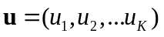 over an interval of time of length T starting at . The corresponding amplitudes are 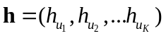. Because a saltation at t₀ cannot be distinguished, we assume 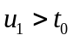. We also have 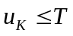 with no saltation observed between 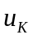 and 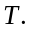 Let 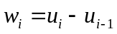 be the i^{th} waiting time between growth events where 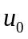 and 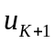 are times associated with the unobserved growth events immediately preceding and following 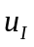 and 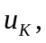 respectively. Therefore, 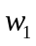 is censored on the left at and 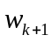 is censored on the right at unless 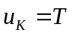.
The true height, 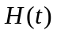 at time t may be represented as the sum of the initial height 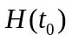 at time and the sum of all succeeding growth amplitudes up to time t. In continuous time this may be written as
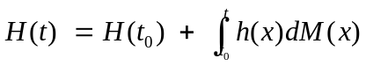
where 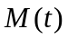 is the counting process associated with u. We actually observe the heights at a set of N times 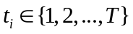. The measured height at time t, 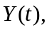 may be written as the sum of the true height and Gaussian measurement error 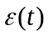 with mean 0 and variance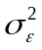.
Representing Y as the N-vector of observed heights, 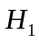 as the initial height at time 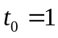, X as a matrix with (i,j)^{th} element equal to one if the time associated with the i^{th} observed height is greater than or equal to u_{j}, 1_{N} as the N-vector of ones and ε as the N-vector of measurement errors, we can write
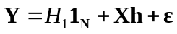.
The likelihood is then
We assume that the amplitudes 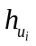are independent and lognormal with 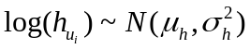 so that the joint distribution of the amplitudes
The waiting times are also assumed to follow a lognormal distribution such that 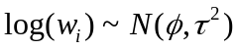. The lognormal distributions allow for skewness in the necessarily positive amplitudes and waiting times. Because the first and last waiting times are censored, the joint distribution of the growth times
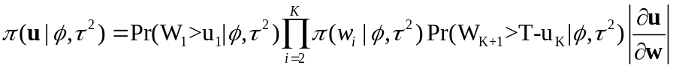.
Using a result from renewal theory on the asymptotic distribution of the excess life, we have

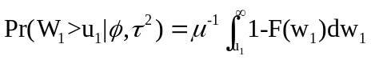

where 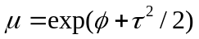 is the mean of the distribution with cumulative distribution function
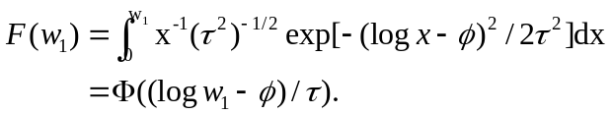
Also,
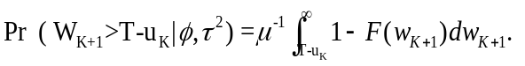
The Jacobian 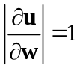 as can be seen by writing down
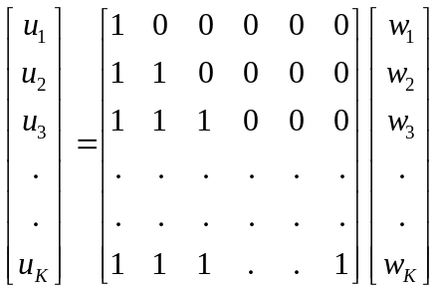.
Finally
.

We use Bayesian inference to estimate model parameters in order to incorporate external information available about them through prior distributions. Representing the joint prior distribution by 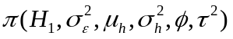, we obtain the posterior distribution as
where the components of the prior distribution are assumed independent and of the form 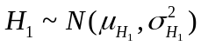, 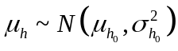, 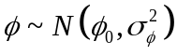,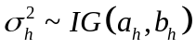, 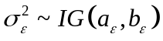 and 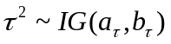.

Reversible Jump Markov chain Monte Carlo Algorithm
Parameters were estimated by reversible jump Markov Chain Monte Carlo (RJMCMC) (Green, 1995) simulating draws from the distribution of the amplitudes and hyperparameters given the the locations of the growth events and simulating the locations of the growth events given the amplitudes and hyperparameters. The reversible jump formulation is necessary because the insertion or deletion of a growth event and corresponding amplitude changes the dimension of the parameter space. Estimation divides cleanly into two parts. First, use the Gibbs and Metropolis-Hastings algorithms to simulate draws from the joint distribution, 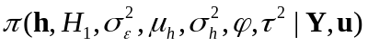, of the amplitudes and hyperparameters given the locations of the growth events. Then, use RJMCMC to simulate draws from the joint distribution, 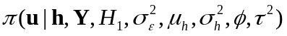, of the locations of growth events given the amplitudes and hyperparameters. The reversible jump formulation permits handling the changing dimension of the parameter space when saltations are added or deleted. The full algorithm consists of a series of eight steps.

1. Draw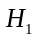 Based on the prior for and the likelihood, sample 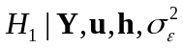 from a normal distribution with mean and variance 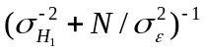.

2. Draw Sample 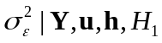 from
.
3. Draw 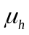 Based on the prior for and the model for h, sample 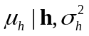 from
4. Draw 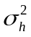 Based on the prior for and the model for h, sample 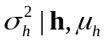 from
.
5. Draw h Because the amplitudes follow a lognormal prior distribution, we require a Metropolis step to circumvent the lack of conjugacy. For a transition density, we use the posterior normal distribution found by combining the likelihood and a normal approximation to the lognormal found by matching the mean and variance. Letting 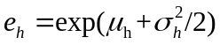 and 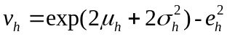, the transition density 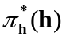 is normal with mean and variance 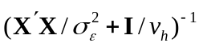. Because h is high-dimensional and restricted to positive values, it is much more efficient to update the amplitudes individually. Thus, for each element h_{i} of the amplitude vector, we use a conditional transition density 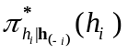 formed by choosing the conditional mean and variance of given the remaining elements 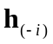 of h. Under the Metropolis-Hastings scheme, at the r^{th} iteration the candidate draw of the i^{th} amplitude, 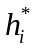, is then accepted with probability equal to 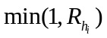 where the Metropolis ratio
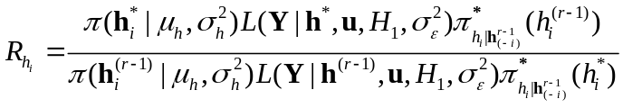,
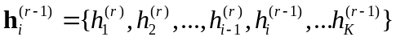 is the current vector of amplitudes and 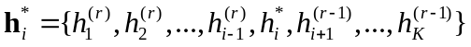 is the candidate amplitude vector.

6. Draw φ  The major difficulty in sampling φ is the complicated density for the waiting times introduced by the censoring at the beginning and end of the observed series. We can approximate this density by ignoring the endpoint corrections and treating the sum of the first and last waiting times as a single time 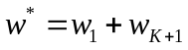. Then,
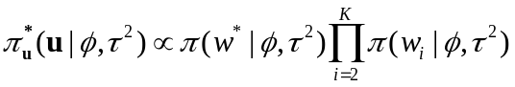
A transition density for φ is then
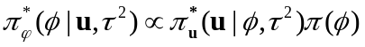
which follows a normal distribution with mean 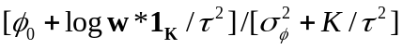and variance 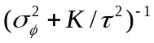 with 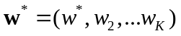. At the r^{th} iteration of the simulation, the candidate draw from the transition density, φ*, is then accepted with probability equal to
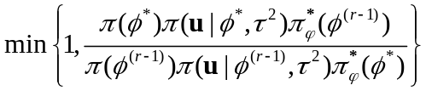.

7. Draw τ² A similar derivation leads to a candidate τ^{2*} drawn from
which is accepted with probability equal to
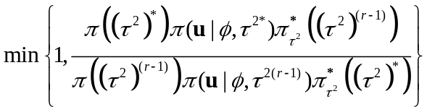.
8. Draw u Simulating u, the vector of growth locations, involves first determining its dimension and then determining its components. Whenever the dimension changes, it is also necessary to change the dimension of the amplitude vector h. Computationally, this can be quite complex so we limit the dimension change to be no more than one. Simulation then involves determining whether to add or subtract a saltation and where to place the insertion or deletion. If the dimension is unchanged, then we permit a shift in the location of the saltations.
Asymptotically, the number of saltations by time t, 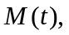 may be expressed probabilistically as
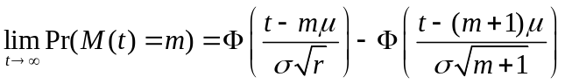
where μ is the mean of the waiting time process and σ² is its variance (Cox and Miller, 1965). This result is used to construct a transition density for 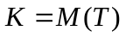 as

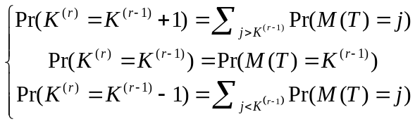
for the probabilities associated with insertion, shift and deletion. The complete transition density for u is then the product of this dimension change probability and the probability of the particular times and amplitudes proposed.
Inserting a saltation Assume that current saltations are located at u^{(r)} with corresponding amplitudes h^{(r)}. First, sample a candidate time for insertion using an empirical likelihood density constructed as follows. At each potential location in 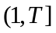 excluding u^{(r)}, insert a saltation and reset the amplitudes bounding the insertion point so that their sum is unchanged and the ratio of amplitudes at the original locations is maintained. If the bounding amplitudes are 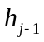 and h_{j}, create new amplitudes 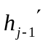, 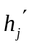 and 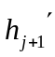 so that
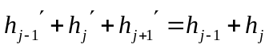
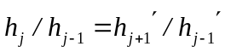
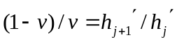

where v is a U(0,1) random number drawn so that the new heights are random within the constraints described above. The solutions to these equations are 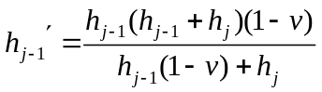, 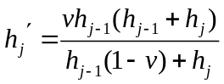 and 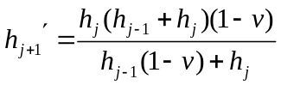. When the candidate location is before the first location or after the last location 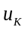, only one bounding location is available. In these cases, the new height is determined by the equations 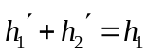 and 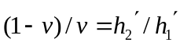 or 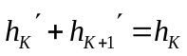 and 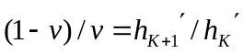 which have solutions 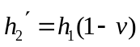 and 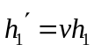 or 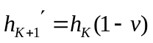 and 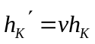, respectively.
At the i^{th} proposed location, 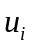, use these new heights to calculate -2 times the log likelihood
where 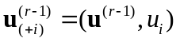 is the complete proposed location vector with corresponding amplitudes 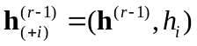. Then, normalize to create a likelihood-based transition density
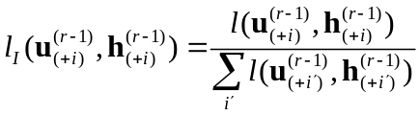
where the sum in the denominator is over all potential insertion locations. The complete insertion proposal density is then 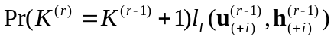.
To determine the acceptance probability of the proposed move requires the probability of the reverse move, a deletion. Deletion uses the same empirical likelihood method. If the location to be deleted is u_{j}, derive the new heights at 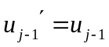 and 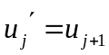 as 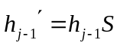 and 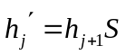 where 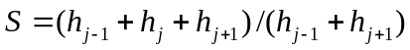. In essence, the new heights are found by collapsing the old heights across the bounding locations while maintaining the ratio of the bounding heights. Matters simplify if the deletion is made at the first or last location because then 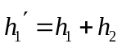 or 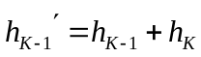. The normalized likelihoods calculated for the new set of locations and amplitudes after deleting location j are then used to choose a location to delete according to the empirical density
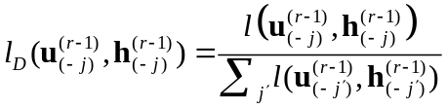
where 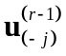 and 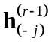 represent the pairs of locations and amplitudes formed by deleting the j^{th} pair from 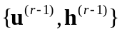 and the sum in the denominator is over all possible deletions. The complete proposal density for deletion is then 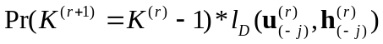.
Denote by u_{add} the particular time and by h_{add} the particular amplitude generated by the transition density. The insertion move from 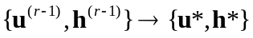 is then accepted with probability
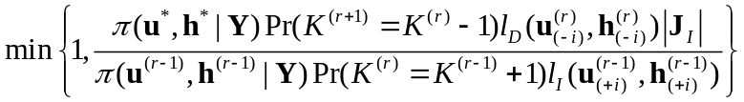
where 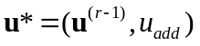 and 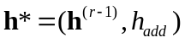 are the new vectors of growth locations and amplitudes selected from the empirical likelihood;

is the joint density of the proposed times and amplitudes;
,
is the joint density of the current times and amplitudes; and 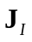 is the Jacobian of the change in variables required by the reversible jump method.
Because the transformation from 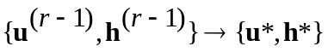only involves the bounding amplitudes and the new location, its Jacobian reduces to 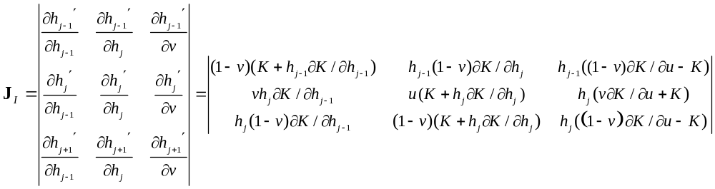
where
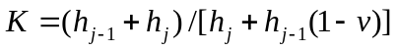,
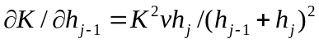,
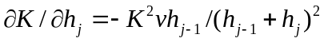
and
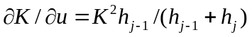.
The term involving the new location disappears because it is set equal to the random number generated from the empirical likelihood. When the insertion is in the first or last position,
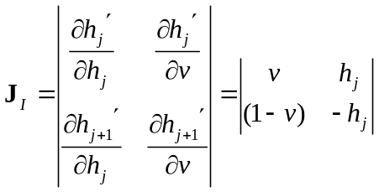.
The term involving the draw of the uniform v is a constant.
The probability of accepting a deletion move equals
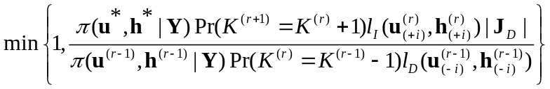

The notation used is similar to that used for representing the insertion step, except that now 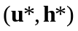 are the new set of locations and amplitudes following deletion. Noting that 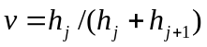, we can write the Jacobian of the transformation 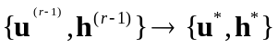 as
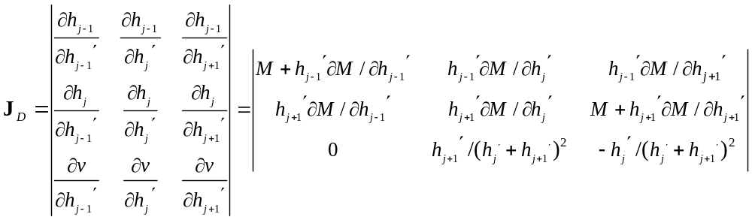
where
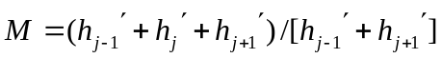,
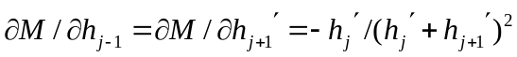
and
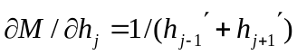.
If 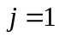or 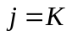, 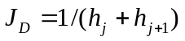.

Shifting Saltations If no change in the dimension of the vector of saltations is indicated, we propose to change the locations by a random deletion of one saltation followed by an insertion at a random new location u_{add}. This deletion/insertion pair is accomplished using the algorithms described above. Denoting the new location and amplitude vectors by 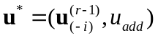 and 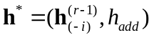, respectively, the probability of accepting the shift move equals
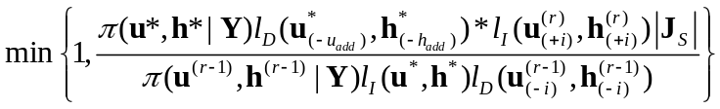.

with Jacobian 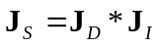. Note that the prior ratio of growth counts cancels in the numerator and denominator of the shift move.

Starting Values
Starting values for the simulation are based on empirical estimates from the data. Intuitively, growth occurs whenever height increases from one day to the next, although apparent growth may reflect measurement error. A simple choice for the initial number of saltations is the number of days for which the mean observed daily height increases more than some prespecified cutoff such as 5 mm. over consecutive days. The days on which these increments occurred and the resulting amounts then serve as starting values for u and h. The growth amplitudes are normalized to sum to the total observed growth. We then calculate the mean and variance of the waiting times defined by the starting times. The resulting mean and variance of the lognormal distribution are used to initialize φ and τ². We initialize μ_{h} as the mean and as the variance of log h. is initialized to the observed mean of the first day's measurements and to the pooled within day variance.
For each model, we saved 5000 iterations from each of three parallel chains after convergence by the Gelman-Rubin diagnostic which measures the ratio of between-chain to within-chain variance for model parameters (Gelman et al., 2003). We monitored the chains every 1000 iterations and determined convergence when the upper 97.5 percentile of each ratio was less than 1.1. The resulting 15000 samples served as the Monte Carlo sample from which inferences were drawn.
To create the three chains, we initialized the simulation at three sets of starting values chosen by simply changing the preliminary cutoff value defining growth to 0.3, 1.0 and 3.0 mm. This provided starting values for u, h, φ, τ², μ_{h} and . Initial values for were obtained by taking the sample pooled within day variance and 0.1 and 10 times this value, whereas was started at the mean of the first day measurements and at two times the sample pooled within day variance above and below the mean.

Model Checking
In addition to examining plots of the model fit to the data and plots of the residuals defined as the difference between the observed heights and the posterior means of the true unobserved heights, we also performed a series of posterior predictive checks to evaluate model adequacy (Gelman et al, 2003).
In particular, to evaluate how closely the model could regenerate characteristics of the data series, we simulated data from the predictive distribution of the outcome and compared summary statistics of these predictions to those from the observed data. Agreement indicates that the postulated model could have realistically generated the observed outcomes. For a given realization of the parameters from the j^{th} iteration of the MCMC algorithm, we calculated the test statistic 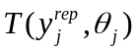, a measure of discrepancy where 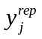is a sample from the predictive distribution 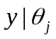. was then compared with 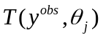 computed using the observed data 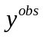 obtaining a Bayesian p-value from 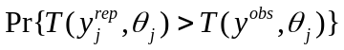. We used the following test statistics where 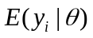 and 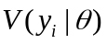 are the mean and variance of the daily height, 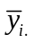 is the mean height over all measurements taken on the i^{th} day and is the indicator function:
- Overall-goodness-of-fit: 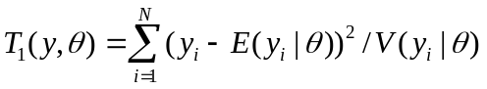;
- Maximal deviation: 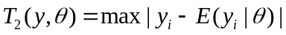;
- Number of positive residuals: 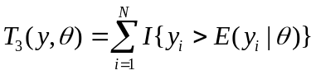
- Number of sign changes (a rough test of serial correlation): 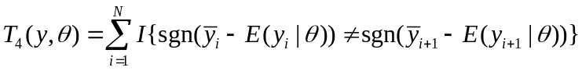;
- Height at the end of observation: 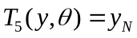;
- Largest growth increment: 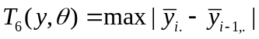;
- Number of decreases in daily mean height: 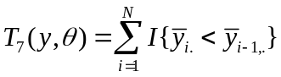;
- Number of days with no variation:
- Largest stasis interval:
and
- Number of growth events: 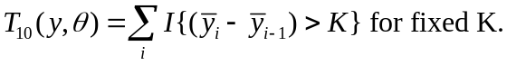

RESULTS

Figure 1 displays daily measurements of body length for two infants (ALPU and KAMU) analyzed by Lampl and colleagues, as well as standing heights for two 12 year old children near puberty (ABS and SBO) and two pre-adolescent children (ITS and GLS) aged 8 and 10, respectively. Each child was measured for periods ranging from 4 to 5 months. The infants were measured between one and six times each day by a maximal stretch technique, applying gentle pressure until the child was at full body length. Replicate measurements were taken successively after repositioning the infant, but the time of the visits varied from day to day (Lampl and Johnson, 1993; Lampl et al, 2001). The four older children were measured three times each evening before bedtime while standing against a wall-mounted stadiometer (model 216 Seca Stadiometer). On a few occasions when measurements conflicted, a fourth or fifth measurement was taken.
Table 1 displays selected percentiles of the prior distributions assumed for the amplitudes, waiting times and measurement error. The prior for is Gaussian with mean and variance derived from age and sex appropriate standard growth curves (http://www.cdc.gov/growthcharts/). A Gaussian shape often represents the distribution of heights in a population. Figure 2 shows the prior distributions for the six children. We take the prior for 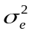 to be inverse gamma 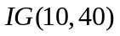 which suggests a median within-day standard error of measurement of 2 mm corresponding to a daily range (2 standard error difference) of 8 mm. The priors 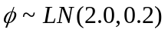, 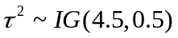 imply a median waiting time between saltations of one week, but do not exclude the possibility of daily growth (waiting time of one day or less). For the amplitude parameters, 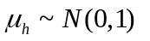and 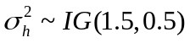imply a median amplitude of 1 mm. with 5th and 95th percentiles of 0.1 mm. and 8.9 mm., respectively. Posterior inference was not sensitive to these priors when we varied the prior parameters across reasonable values. Only use of priors that unreasonably put almost all support on long waiting times significantly affected posterior inferences.
Figure 3 displays the median and central 95 percent probability interval of the six posterior distributions for daily amplitude. Each plot demonstrates daily growth, but with amounts that vary substantially. Long intervals of minute growth separate isolated one or two day periods of more substantial growth. The posterior probability of growth was exactly or very nearly one on each day. Growth was continuous, but often resembled a saltatory pattern.
The daily amplitudes and relative periods of stasis varied considerably across children. ALPU grew more than 4 mm. on 13 separate days which accounted for 80 percent of his total growth, while KAMU had 11 days of substantial growth accounting for 2/3 of her total growth. The four older children exhibited much less day-to-day variation. Although ABS grew nearly 10 mm. on one day, this was the only day on which she grew more than 4 mm. ITS and GLS never grew 4 mm. in a single day, while SBO had only a single day of such substantial growth. Altogether, the two infants had 23 days between them in which the posterior mean growth differed significantly from zero, whereas the four children had only two. Rather than growing substantially on a single day, the four older children generally had periods of several days or even weeks when they grew consistently in small amounts each day and periods of no growth. Nevertheless, the two adolescents each exhibited one day of substantial growth. Because adolescence and infancy are periods of rapid growth, this suggests that intense growth is characterized by growth events with larger amplitudes.
To investigate the concept of irregular intervals of growth or “mini-growth spurts”, let us examine the growth pattern of KAMU more closely. In addition to the distribution of daily growth, we can use the MCMC simulations to calculate the amount of growth over multiple days. Although the posterior distributions of daily growth are skewed so that the mean exceeds the median, as daily amounts are added together, their sum becomes more like a normal distribution. Approximately, therefore, we can focus on means rather than medians. For example, while the median growth was 9.9 mm. on day 1 and 0.1 mm. on day 2, the median total growth over days 1 and 2 combined was 10.4 mm. The combined mean is also 10.4 mm. as, of course, is the sum of the two daily means.
Examination of summed growth across all possible pairs, triplets, and so forth, reveals that the growth plot in Figure 3 indicates periods of nearly certain and uncertain growth. In addition to the 11 single days on which KAMU certainly grew, there were several other periods of two or more days over which she certainly grew, but for which the growth could not certainly be attributed to a single day. Table 2 provides an example covering the period from day 16 to day 20. Although some growth (at least greater than 0.1 mm.) more than likely occurred on each of these five days, it is certain that growth greater than 0.5 mm. (i.e., greater than 0.1mm./day) occurred on the 5 days combined. Furthermore, even though the lower limit of a 95% central probability interval for single day growth was always essentially zero, the lower limit on the summed growth was 3.15 mm. Similar periods of substantial growth over successive days occurred during days 25-31 (mean growth 1.2 mm.), 46-48 (0.8 mm.) 51-54 (2.1 mm.) 61-65 (2.4 mm.) 66-73 (1.6 mm.), 75-79 (3.5 mm.) and 109-112 (3.7 mm.). Added to the growth on days 1, 4, 14, 37, 45, 55, 74, 97, 100, 121 and 122, total growth for this set of 47 days was 85 mm compared with a total of 12 mm. on the remaining 75 days. In other words, this infant accomplished 88% of her growth in only 39% of the time available. Similar patterns show up for all six children.
The predicted cumulative growth curves, together with 95% central posterior intervals for achieved height on each day are shown overlaid on the data in Figure 4. The pattern of growth spurts is apparent as are periods of no or extremely minute growth.The posterior mean standard errors of measurement ranged between 1.6 and 2.4 mm. with the smaller values observed for the infants (Figure 5). The posterior distributions of the initial heights concentrated within about 2 mm. of the sample mean of the first day's measurements (Figure 6).
Model Sensitivity
We carried out a series of additional analyses to investigate model adequacy and robustness. In general, the model reproduced the data features checked finding no lack of overall fit. The Bayesian p-values resulting from the posterior predictive checks (Table 3(a)) did suggest, however, that within-day measurements for four of the children were more consistent than predicted by the model, that ABS had one day of rapid growth greater than expected under the model, and that the two infants had more saltatory growth than expected under the model.
We also investigated the sensitivity of the model to assumptions about the distributional form of the amplitudes by replacing the lognormal form by a Gaussian distribution such that 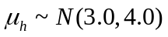 and 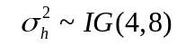. Figure 7 shows that Gaussian amplitudes tended to oversmooth, missing large amplitudes and failing to distinguish high growth from low growth days, particularly for the infants and on day 104 for ABS. Table 3(b) demonstrates that, although the Gaussian amplitude model satisfies the general goodness of fit criterion, it fails those posterior predictive checks involving the large daily differences present in the data. We can also directly compare the lognormal and Gaussian models by calculating
where 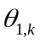and 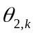represent the 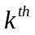 set of simulated parameters under the two models (Table 2(c)). The lognormal prior not only captures saltations better, but also fits periods of slow growth.

DISCUSSION
Our results suggest a resolution to the controversy between saltatory and continuous growth. Growth is continuous, but episodic. It occurs on a daily basis with high probability, but the amount varies considerably from day to day. Considering the very small amounts of growth that are indicated on many days, growth is essentially saltatory, consisting of considerable stretches of time over which children hardly grow and much shorter stretches over which they grow substantially.
These results imply that growth is a synchronized biological process involving a system of on-off switches that regulate human metabolism and signal the body when to grow and by how much. Cell cycle research indicates that cells have both active and inactive growth phases and normal growth-inhibitory mechanisms controlled by different proteins (Sherr, 1996). The existence of saltation and stasis would suggest a coordination of multiple cellular processes that regulate the active and inactive phases. Both animal and cellular studies in bone growth support this hypothesis of synchronization (Wilsman et al, 1996, 1999), but details of the process are lacking. If true, however, this theory has major implications for understanding both the physiology and pathophysiology of growth at the level of the cell and the organism, for properly managing normal growth and for treating growth disorders. (Lampl, Veldhuis and Johnson, 1992). Characterization of the components that induce variation in growth is a crucial first step in understanding these processes
Our model predicts amounts of total growth over the 4-5 month followup period that agree well with standard growth charts. As constructed, the model therefore applies reasonably well to a single individual measured over a short duration of time. But the variation observed in the distribution of amplitudes across individuals indicates that a general model for the population needs an additional between-subject component describing the effect of covariates like age, gender, nutritional intake and other physiologic or environmental growth factors. Furthermore, such components would need to change with time to reflect the different stages of growth.
The variation in measurement error also suggest several potential enhancements to the model and measurement protocol. The measurements on the infants differ from those of the older children not just in their larger amplitudes, but also in their smaller measurement variation as seen in Figure 4. Undoubtedly, some of the discrepancy relates to the differences in measurement protocols. However, there may be other reasons for these differences. The excess of the estimated standard errors of measurement (ranging from 1.6 to 2.4 mm) relative to the estimate of true random error from the pooled within-day standard deviations (ranging from 0.3 to 2.0 mm) supports the presence of a systematic between-day error component. Between-day differences may represent true growth or systematic misestimation of true height resulting from unmeasured exogenous sources. Both muscle tension and soft tissue hydration can lead to positioning errors that might cause measurements to vary systematically across days. Fatigue, intense activity and contrariness can increase muscle tension. Fluctuations in soft tissue hydration result from variation in general health or activity and from growth (Lampl et al, 2001). Failure to incorporate these systematic between-day components of variance could explain why the model consistently underestimates the number of days with no within-day variation. Measurements can also vary systematically within-day if individuals are measured at different times of the day. Although all four older children were always measured in the evening, the two infants were not measured at a consistent time every day. As measurement variation was smaller among the infants, however, systematic within-day sources of variation may not be as important as between-day sources or differences in measurement protocol.

ACKNOWLEDGEMENTS
The authors would like to thank Gretchen Schmid, Ian Schmid, Anna Schmid and Sam Ogren for participating as subjects and contributing data. We also appreciate the two data series kindly given to us by Michelle Lampl and Mike Johnson. Genentech Corporation donated the Model 216 Seca Stadiometers used in this project.

REFERENCES
1. Chany C, Kaba A, Ilunga AL and Dubousset J. Interferon and sarcolectin as regulators of coordinated discontinuous cell growth. In: Saltation and Stasis in Human Growth and Development: Evidence, Methods and Theory, edited by Lampl M. London: Smith-Gordon, 1999, p. 19-26.
2. Cox DR and Miller HD. The Theory of Stochastic Processes, New York: Chapman and Hall, 1965.
3. Gelman A, Carlin JB, Stern HS and Rubin DB. Bayesian Data Analysis, 2nd ed. New York: Chapman and Hall, 2003.
4. Goldsmith MI, Fishser S, Waterman R and Johnson SL. Saltatory control of isometric growth in the zebrafish caudal fin is disrupted in long fin and rapunzel mutants. Developmental Biology 259: 303-317.
5. Green PJ. Reversible jump Markov Chain Monte Carlo computation and Bayesian model determination. Biometrika 82: 711-732, 1995.
6. Heinrichs C, Munson PJ, Counts DR, Cutler GB and Baron J. Patterns of human growth. Science 268: 442-445, 1995.
7. Hermanussen M, Thiel C, von Buren E, Rol de Lama MA, Perez Romero A, Ariznaverreta Ruiz C, Burmeister J and Tresguerres JA. Micro and macro perspectives in auxology: findings and considerations upon the variability of short term and individual growth and the stability of population derived parameters. Annals of Human Biology 25: 359-385, 1998.
8. Johnson ML, Veldhuis JD and Lampl M. Is growth saltatory? The usefulness and limitations of distribution functions in analyzing pulsatile data. Endocrinology 137: 5197-5204, 1996.
9. Lampl M, Birch L, Picciano MF, Johnson ML and Frongillo EA. Child factor in measurement dependability. American Journal of Human Biology 13: 548-557, 2001.
10. Lampl M and Johnson ML. A case study of daily growth during adolescence: a single spurt or changes in the dynamics of saltatory growth? Annals of Human Biology 20: 595-603, 1993.
11. Lampl M, Cameron N, Veldhuis JD and Johnson ML. Response to patterns of human growth. Science 268: 445-447, 1995.
12. Lampl M, Veldhuis JD, and Johnson ML. Saltation and Stasis: a model of human growth. Science 258: 801-803, 1992.
13. Sherr CJ. Cancer cell cycles. Science 274: 1672-1677, 1996.
14. Wilsman NJ, Farnum CE, Leiferman EM, Fry M, Barreto C. Differential growth by growth plates as a function of multiple parameters of chondrocytic kinetics. Journal of Orthopedic Research 14: 927-936, 1996.
15. Wilsman NJ, Farnum CE, Leiferman EM, Lampl M. Growth plate biology in the context of growth by saltations and stasis. In: Saltation and Stasis in Human Growth and Development: Evidence, Methods and Theory, edited by Lampl M. London: Smith-Gordon, 1999, p. 19-26.
FIGURE LEGENDS
Figure 1. Daily height measurements for six children.

Figure 2. Prior distributions of initial height 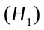 for six children derived from age and sex appropriate population growth curves.

Figure 3. Posterior distributions of daily amplitudes for each child including median (diamond) and 95% central posterior interval (error bars).

Figure 4. Posterior distribution of cumulative height with 95% central posterior interval bounds superimposed on raw data (filled circles).

Figure 5. Prior (dotted line) and posterior (solid line) distributions for measurement error variance.

Figure 6. Posterior distributions of initial height for six children. Crosses represent first day measurements; filled square denotes sample mean of first day measurements.

Figure 7. Posterior distribution of cumulative height under lognormal and normal amplitude models for six children. Raw data shown as filled circles. In all plots, the normal model is represented by the smoother curve that has smaller saltations.

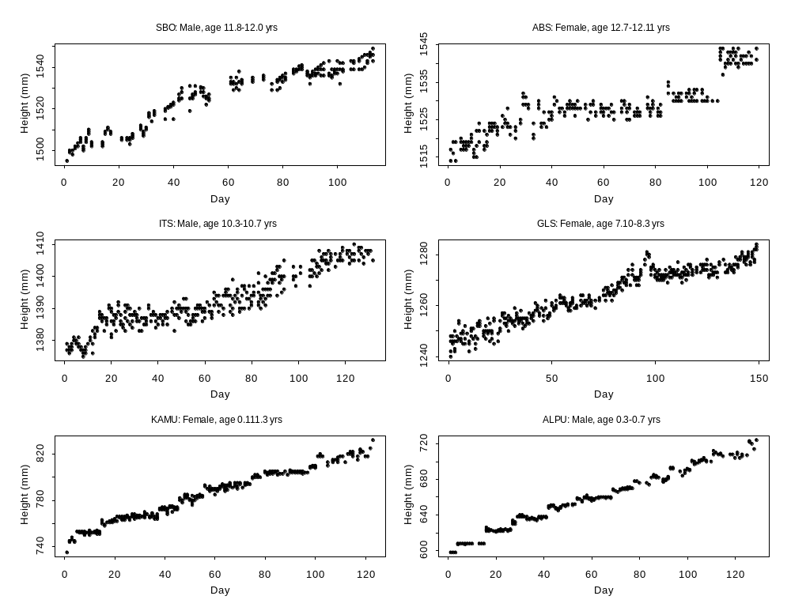
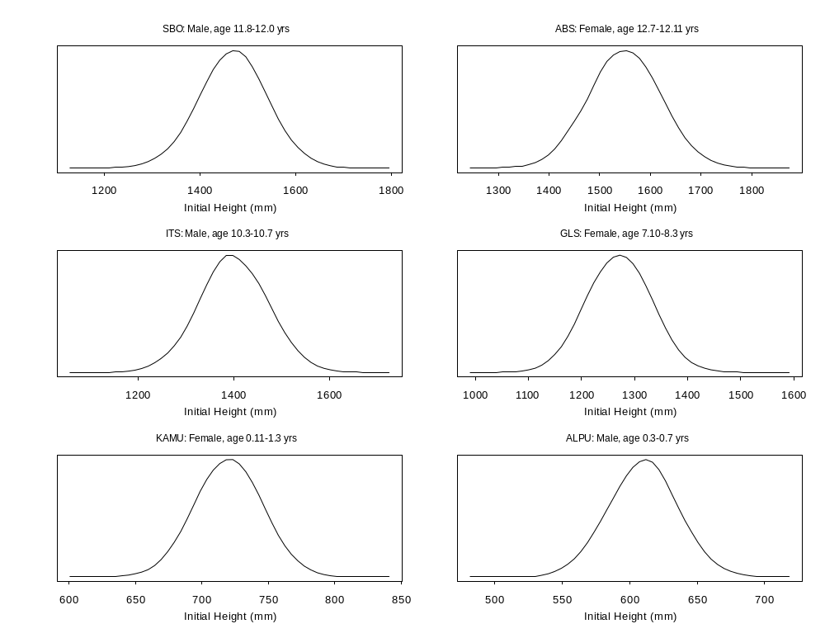

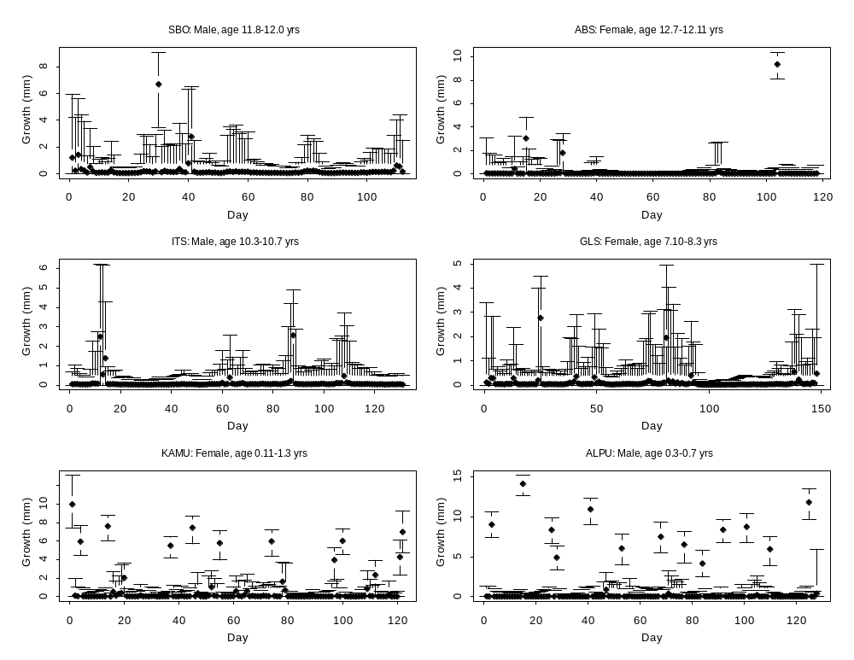

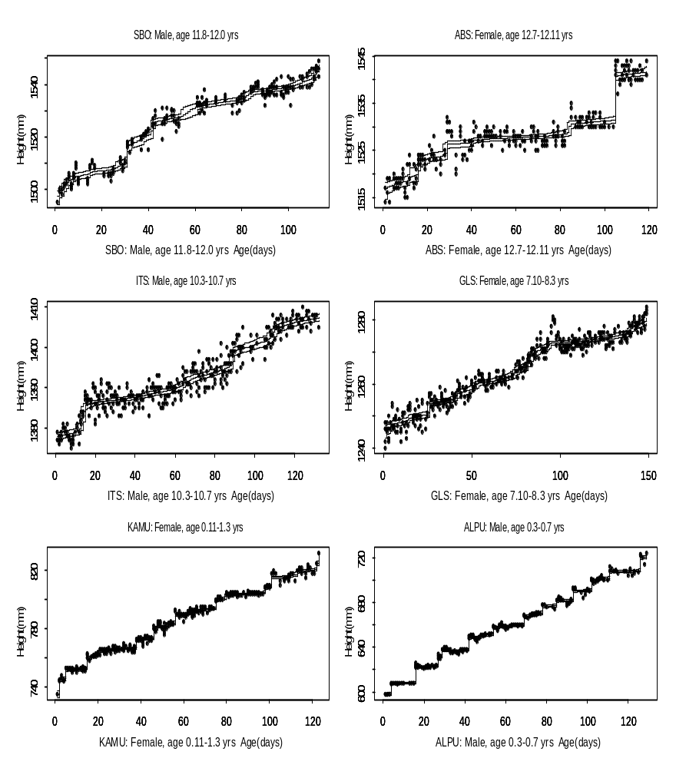

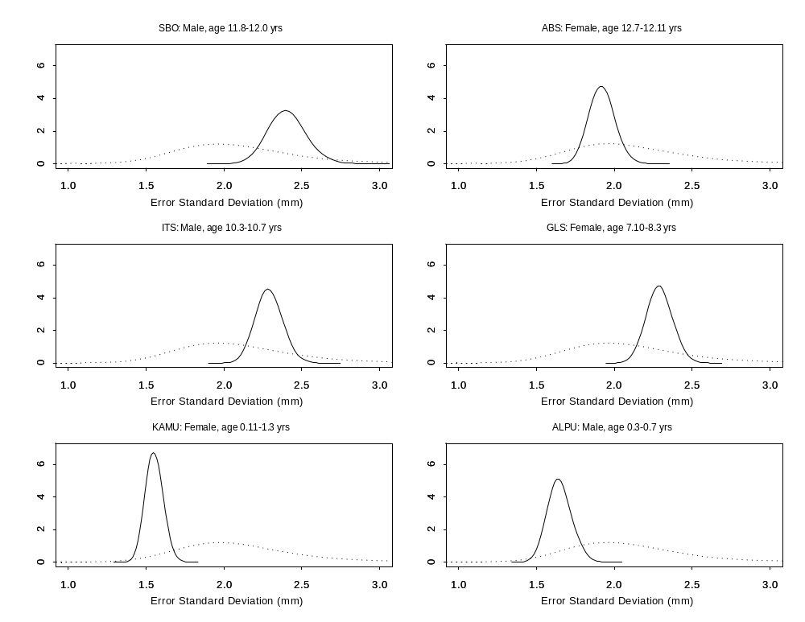

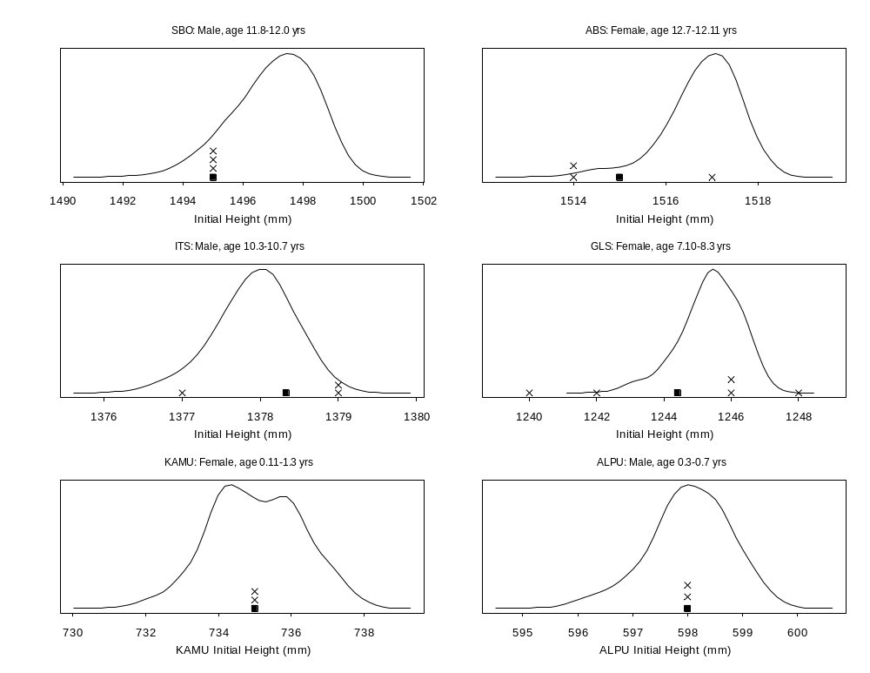

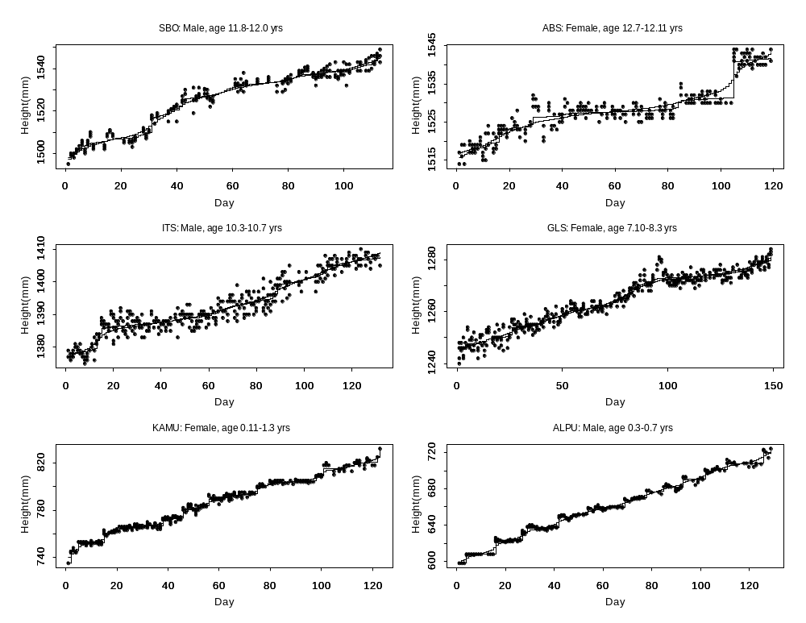
Table 1. Selected percentiles implied by the prior distributions on the hyperparameters.
 | Waiting Times (days) | Amplitudes  (mm) | Measurement Error Variance (mm)
Percentile | (w_{i}) | (h_{i}) | (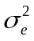)
0.1 | 1.2 | 0 | 1.8
1 | 1.9 | 0.04 | 2.1
5 | 2.9 | 0.1 | 2.5
25 | 5.1 | 0.4 | 3.4
50 | 7.5 | 1.0 | 4.1
75 | 10.9 | 2.4 | 5.2
95 | 19.4 | 8.9 | 7.5
99 | 28.8 | 28.3 | 9.8
99.9 | 50.3 | 452 | 12.4

Table 2. Selected percentiles implied by the prior distributions on the hyperparameters.
Day(s) | Mean | 2.5th  Percentile | 97.5th  Percentile | Pr(Growth > 0.1 mm./day)
16 | 0.779 | 0.001 | 2.657 | 0.722
17 | 0.344 | 0.000 | 1.675 | 0.524
18 | 0.615 | 0.001 | 2.234 | 0.659
19 | 0.930 | 0.001 | 3.459 | 0.657
20 | 1.852 | 0.005 | 3.638 | 0.904
16-20 | 4.521 | 3.150 | 5.992 | 1.000
Table 3. Bayesian p-values from posterior predictive checks for six children.
(a) Probability that observed statistic is less than one randomly generated from the distribution of those expected under the lognormal model for amplitudes. Large p-values indicate observed statistic is small relative to expected; small p-values indicate observed is large relative to expected. Bolded entries are those in upper and lower 2.5 percent tails which suggest that model does not agree with observed data.

 | Child
Criterion | SBO | ABS | ITS | GLS | ALPU | KAMU
Goodness of Fit | 0.41 | 0.49 | 0.45 | 0.47 | 0.61 | 0.65
Maximum Deviation | 0.73 | 0.35 | 0.50 | 0.08 | 0.44 | 0.45
#Positive Residuals | 0.35 | 0.52 | 0.37 | 0.84 | 0.29 | 0.40
#Residual Sign Changes | 0.82 | 0.79 | 0.63 | 0.57 | 0.95 | 0.52
Last Day Height | 0.31 | 0.39 | 0.95 | 0.14 | 0.19 | 0.43
Largest Increment | 0.60 | 0.02 | 0.84 | 0.33 | 0.18 | 0.64
Sum of 3 largest increments | 0.56 | 0.004 | 0.69 | 0.16 | 0.06 | 0.32
#Height Decreases | 0.98 | 0.50 | 0.44 | 0.21 | 0.38 | 0.34
#Days with no variation | 0.50 | 0.001 | 0.001 | 0.15 | <0.001 | <0.001
Largest stasis interval (K=0.5 mm) | 0.15 | 0.15 | 0.79 | 0.81 | 0.79 | 0.07
Largest stasis interval (K=5 mm) | 0.33 | 0.94 | 0.10 | 0.92 | 0.78 | 0.77
#Growth events (K= 0.5 mm) | 0.007 | 0.95 | 0.33 | 0.18 | 0.99 | 0.60
#Growth events (K= 5 mm) | 0.36 | 0.11 | 0.85 | 0.06 | 0.01 | 0.001

 | Child
Criterion | SBO | ABS | ITS | GLS | ALPU | KAMU
Goodness of Fit | 0.37 | 0.44 | 0.43 | 0.44 | 0.36 | 0.50
Maximum Deviation | 0.66 | 0.27 | 0.77 | 0.06 | 0.66 | 0.27
#Positive Residuals | 0.20 | 0.54 | 0.53 | 0.91 | 0.68 | 0.35
#Residual Sign Changes | 0.98 | 0.99 | 0.97 | 0.67 | >0.999 | 0.89
Last Day Height | 0.41 | 0.77 | 0.99 | 0.10 | 0.12 | 0.008
Largest Increment | 0.18 | <0.001 | 0.75 | 0.26 | 0.006 | 0.004
Sum of 3 largest increments | 0.20 | 0.0007 | 0.56 | 0.12 | <0.001 | <0.001
#Height Decreases | 0.97 | 0.43 | 0.35 | 0.18 | 0.26 | 0.03
#Days with no variation | 0.43 | 0.0 | 0.001 | 0.12 | <0.001 | <0.001
Largest stasis interval (K=0.5 mm) | 0.13 | 0.08 | 0.73 | 0.76 | 0.86 | 0.14
Largest stasis interval (K= 5 mm) | 0.44 | 0.90 | 0.15 | 0.93 | 0.90 | >0.999
#Growth events (K= 0.5 mm) | 0.005 | 0.99 | 0.47 | 0.25 | >0.999 | >0.999
#Growth events (K= 5 mm) | 0.20 | 0.04 | 0.77 | 0.04 | 0.14 | <0.001
(b) Probability that observed statistic is less than one randomly generated from the distribution of those expected under the normal model for amplitudes. Large p-values indicate observed statistic is small relative to expected; small p-values indicate observed is large relative to expected. Bolded entries are those in upper and lower 2.5 percent tails which suggest that model does not agree with observed data.

(c) Probability that random deviation of observed from expected generated under lognormal model is greater than one generated under normal model. Large p-values indicate fit from lognormal is inferior to fit from normal model; small p-values indicate fit from lognormal is superior. Bolded entries are those in upper and lower 2.5 percent tails which indicate disagreement between models.

 | Child
Criterion | SBO | ABS | ITS | GLS | ALPU | KAMU
Goodness of Fit | 0.50 | 0.46 | 0.51 | 0.49 | 0.48 | 0.51
Maximum Deviation | 0.51 | 0.44 | 0.48 | 0.39 | 0.31 | 0.38
#Positive Residuals | 0.43 | 0.51 | 0.52 | 0.43 | 0.56 | 0.51
#Residual Sign Changes | 0.24 | 0.17 | 0.20 | 0.49 | 0.10 | 0.34
Last Day Height | 0.55 | 0.36 | 0.26 | 0.55 | 0.36 | 0.05
Largest Increment | 0.49 | 0.009 | 0.62 | 0.51 | 0.02 | 0.09
Sum of 3 largest increments | 0.43 | 0.06 | 0.60 | 0.47 | 0.004 | 0.001
#Height Decreases | 0.54 | 0.50 | 0.49 | 0.48 | 0.46 | 0.18
#Days with no variation | 0.52 | 0.35 | 0.46 | 0.47 | 0.06 | 0.31
Largest stasis interval (K=0.5 mm) | 0.50 | 0.51 | 0.53 | 0.52 | 0.54 | 0.45
Largest stasis interval (K= 5 mm) | 0.48 | 0.45 | 0.50 | 0.49 | 0.43 | 0.44
#Growth events (K= 0.5 mm) | 0.47 | 0.40 | 0.48 | 0.49 | 0.29 | 0.28
#Growth events (K= 5 mm) | 0.47 | 0.40 | 0.48 | 0.49 | 0.29 | 0.28

